*For training purposes only*

Derivative Classification Required Markings
*For training purposes only*

As of 2021 Marking guide, all final documents or materials, regardless of the media, must have required markings as shown below.
SECRET//NOFORN
(NOTE: This page is Unclassified when removed from contents)

(U) Properly Marking a Title Page for
Classified Material

June 21, 2013

2400 Palm Bay Road NE
Palm Bay FL 32905

Classified By: Employee ID #123456 (Unique Identifier)

Derived From: XYZ Security Classification Guide (SCG), Agency,
Dated, June 21, 2003
Downgrade to: if req on date: if req

Declassify On: 20280621 (yyyymmdd) from date document was created

SECRET//NOFORN

- OVERALL
CLASSIFICATION
IN CAPS ONLY

*Note: Title or
Subject portion
marking is now
required to be in
front.

2. Unclassified Title or Subject

3. Date of
Preparation

4. Name and Address of Generating Facility

5. Classified By
*Note: Classified By is a new marking requirement.

6. Derived From

7. Declassify On
(Date or Event)
- OVERALL
CLASSIFICATION
SPELLED OUT

- Additional caveat markings may be required (e.g., NOFORN, NATO, CNWDI, FGI) for special types of material.

- If derived from multiple sources, include a listing of the source materials in, or attached to, each derivatively classified document/material. The listing may be in the form of a bibliography identifying the creator, title, and date of each source.

- Each page must have overall classification top and bottom and have Portion Markings. All markings indicated above are required for title page. Note that the classification will now proceed the title.

- Consult your local security representative for any classified marking questions.

8. Example of Portion Markings for Internal Pages –

(S//NF) The highest overall classification of the document will be annotated on the top and bottom of every page or you may identify the overall classification of each page independently.

(U) Each section, part, paragraph, graph/picture/photograph or similar portion of material containing classified information shall be portion marked to indicate the highest level of classification.

*For training purposes only*

PROPER MEDIA LABEL
*For training purposes only*

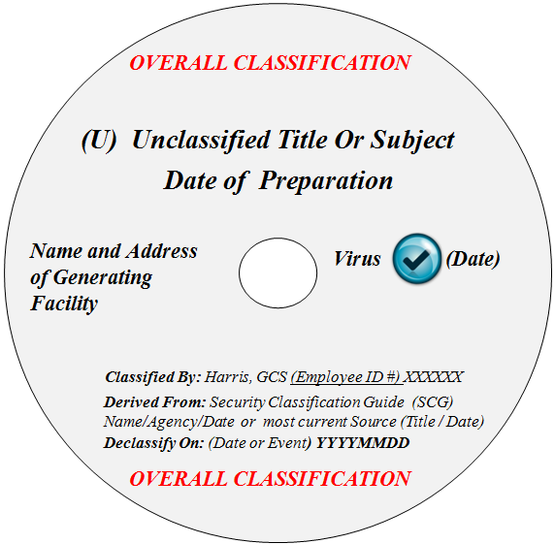

Title page markings and classification level for media must follow the same requirements as documents

*For training purposes only*

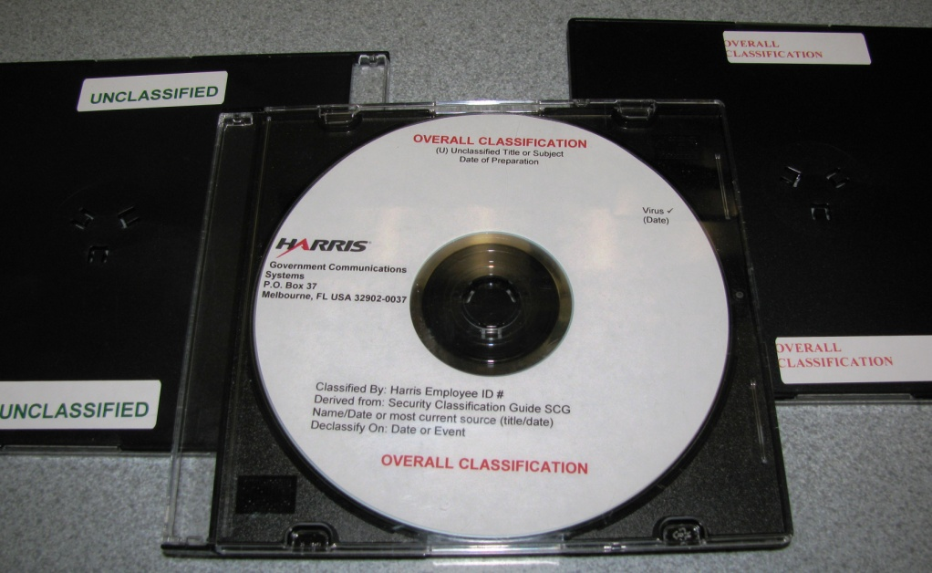
Front cover of case does not need to be labeled if the CD is visible

Back cover requires back of the case be marked with overall classification, including unclassified if stored with classified

PROPER HARD DRIVE LABEL
*For training purposes only*

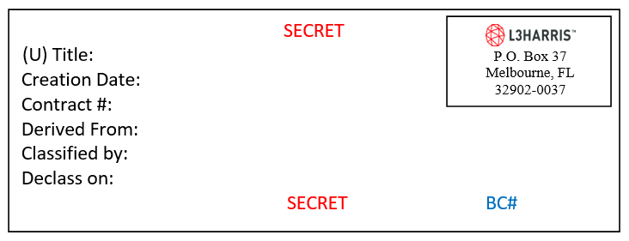
Asset manager’s EID
Serial number

Sticker shall be directly affixed to the HD/SSD – If asset is part of an active system where inspection of the drive is not feasible, affix additional nexus sticker to the outside of the asset – see example below.

For devices too small, use a toe tag

You may add information to the sticker, i.e. barcode number or serial number, but you may not omit any required information, i.e. classification header and footer, unclassified title, creation date, derived from, classified by, declass on or address of generating facility.

Front of device should be marked with a classification sticker or the entire rack can be marked with classification stickers on top and bottom.

*For training purposes only*

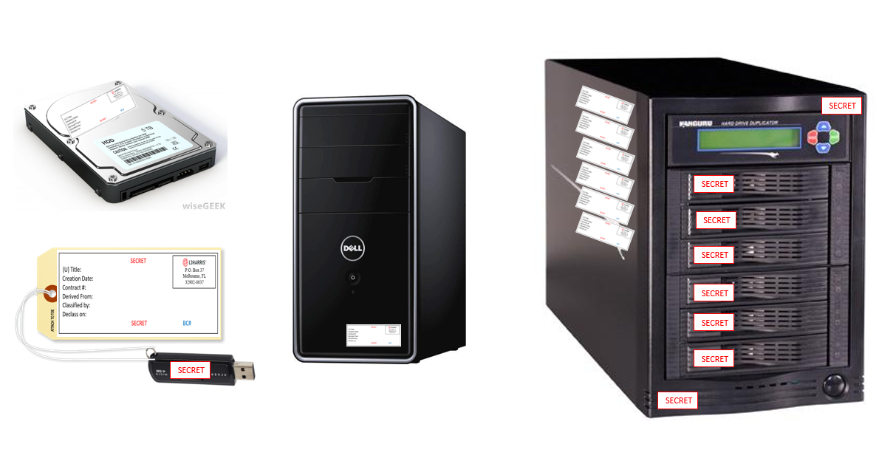
Marked HD with nexus sticker
*For training purposes only*

SPECIAL MEDIA

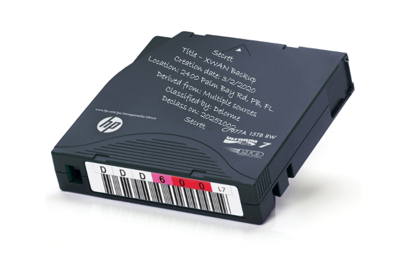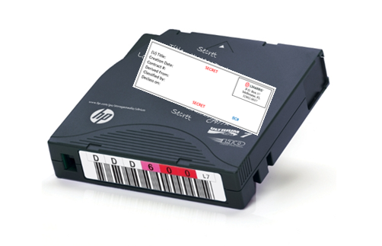
Handwrite classification information on LTOs or place a sticker

*For training purposes only*

*For training purposes only*

SPECIAL INFORMATION MARKINGS

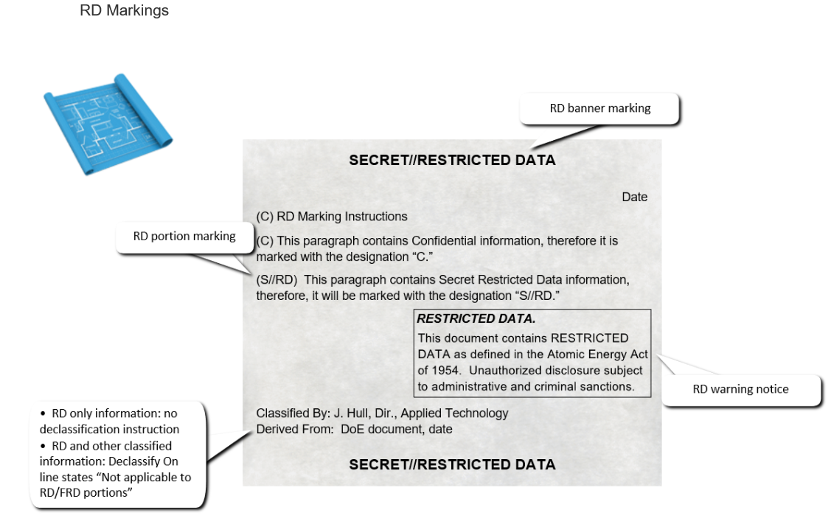
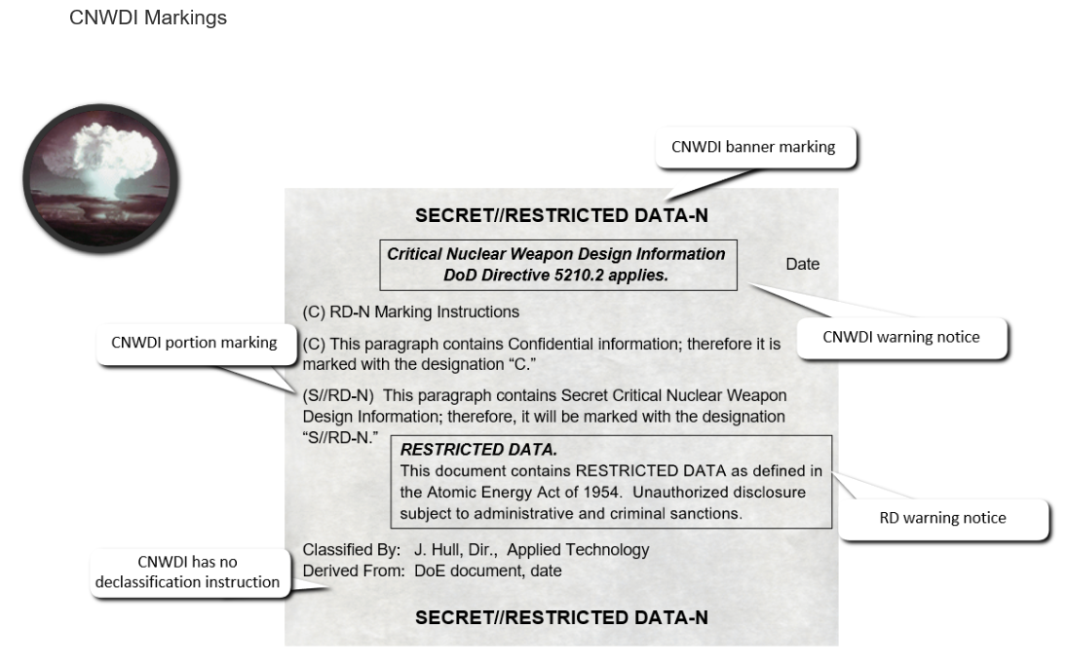

*For training purposes only*

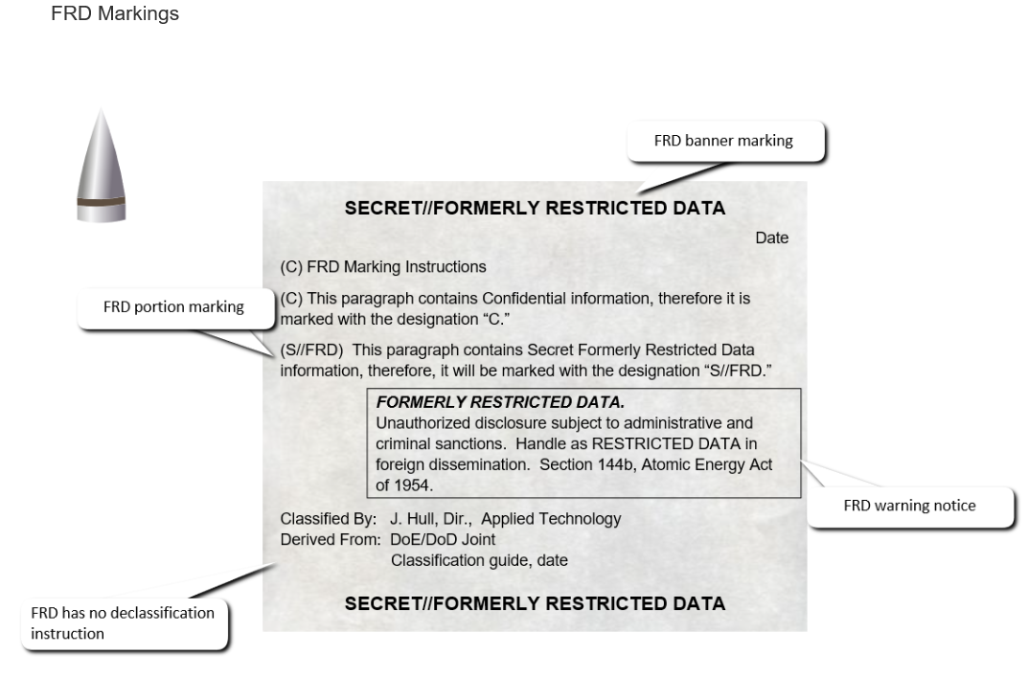
*For training purposes only*

